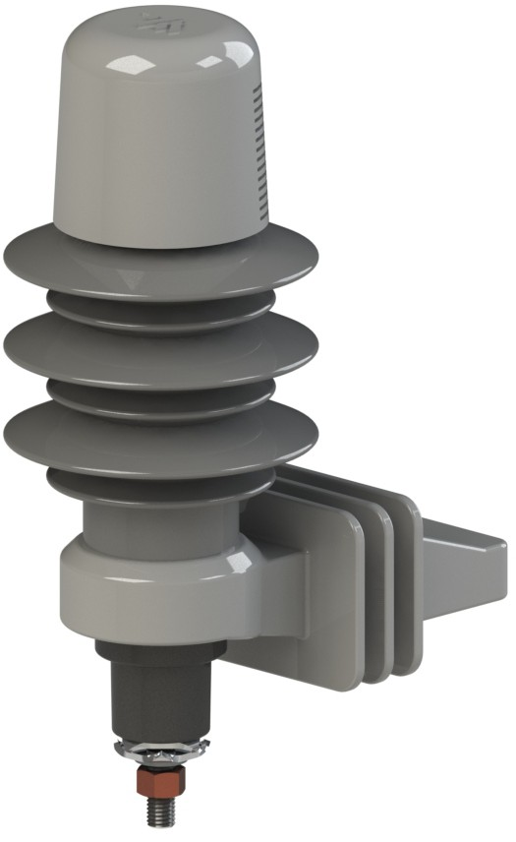


Distribution Arresters

Heavy Duty & Riser Pole Arresters
- Tested to the latest IEEE C62.11 standards
- High Strength Fiberglass Isolator Brackets
- Ground Lead Disconnect will operate with a minimum of 1 amp
- Protective Cap
- RUS Approved
- Directional Option Available

RUS Approved

Distribution Arresters

Heavy Duty & Riser Pole Arresters
Best in class design. Complete offering has passed the latest ANSI/IEEE standards and are RUS approved.

Our arrester terminal options include Stainless steel stud, washers, and wire clamps with silicon bronze nut.

The stainless steel protective cap wrap around design protects the top edge of the insulator and provides an area for the arrester’s specifications to be engraved.

The aluminum alloy electrode is threaded, glued, and pinned into the tube structure. Benefits are:
- Eliminates extreme pressure spikes during surges.
- Resists rotation from tightening hardware.
- Prevents movement from vibration and temperature cycles

Seamless tube provides the best choice for arrester housings
- Ultimate structural integrity throughout the arrester housing compared to other methods (wrap / cage)
- Precision dimensional control for tighter tolerance

Proprietary blended silicon rubber fully encapsulates arrester stack.
  - Hermetically sealed
  - No chance of air/water ingress
  - Sheds sized and shaped for optimized insulating properties

Isolator bracket constructed using high strength fiberglass
  - UV resistant
  - Flame resistant
  - Solid body
  - Universal design for size interchangeability
  - Three sizes available

Ground lead disconnect meets all of the most current IEEE testing requirements
  - External mount for easier identification of operation
  - No wrench design to alleviate potential damage
  - Superior low current performance

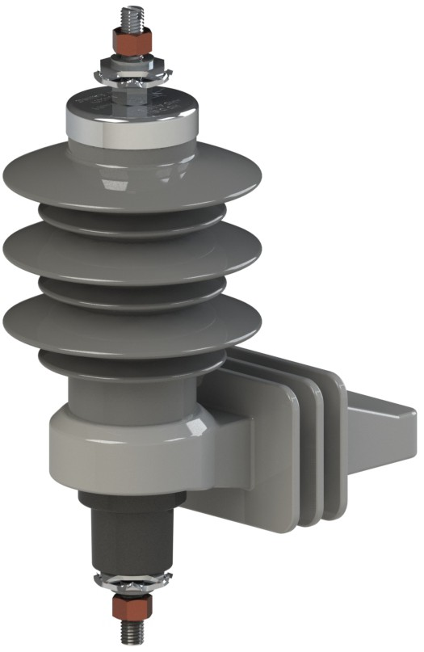
Optional wildlife protector allows for isolation of connections
  - UV resistant
  - Impact resistant
  - High Profile for maximum internal volume
Titan Arrester has zero electrical losses through the MCOV disks during normal and TOV conditions, excluding the losses across the surface of the sheds which is highly dependent on pollution levels.

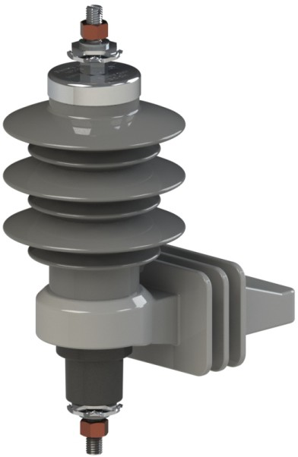
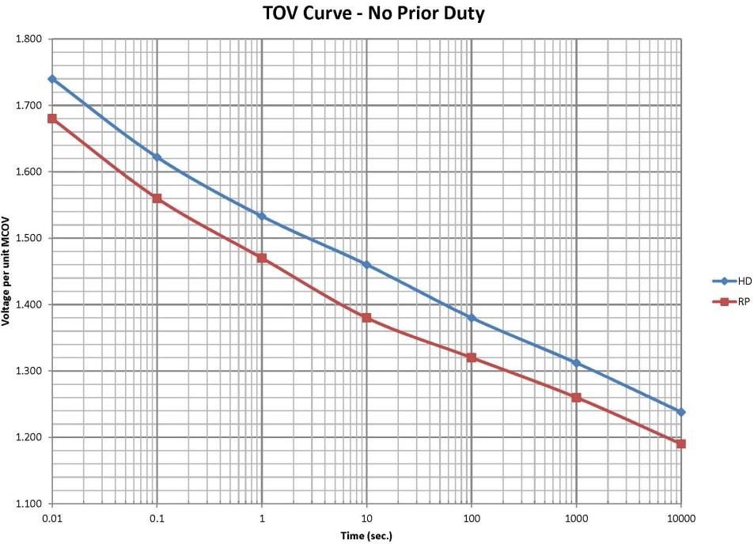
Distribution Arresters
Heavy Duty Arrester Characteristics

Rated Voltage  3 | MCOV | FOW | Switching |  |  | Lightnin | g - 8/20
 |  |  |  | 1.5kA | 3kA | 5kA | 10kA | 20kA | 40kA
Rated Voltage  3 | 2.55 | 10.3 | 7.5 | 7.8 | 8.4 | 8.7 | 9.4 | 10.7 | 12.5
6 | 5.1 | 20.4 | 14.9 | 15.6 | 16.8 | 17.2 | 18.6 | 21.2 | 24.8
9 | 7.65 | 30.5 | 22.2 | 23 | 24.9 | 25.7 | 27.8 | 31.7 | 37.2
10 | 8.4 | 33.8 | 24.1 | 25.2 | 27.1 | 28.3 | 30.7 | 34.8 | 40.8
12 | 10.2 | 40.4 | 29.2 | 30.4 | 32.8 | 34.1 | 37 | 42.2 | 49.4
15 | 12.7 | 50.5 | 36.5 | 38.1 | 41 | 42.8 | 46.2 | 52.7 | 61.7
18 | 15.3 | 60.6 | 43.4 | 45.3 | 49.2 | 51 | 55.4 | 63.2 | 73.9
21 | 17 | 70.7 | 51.1 | 53.1 | 57 | 59.4 | 64.5 | 73.6 | 86.1
24 | 19.5 | 80.8 | 58.4 | 60.8 | 65.2 | 67.8 | 73.6 | 84 | 98.4
27 | 22 | 90.9 | 65.7 | 68.4 | 73.4 | 76.4 | 82.8 | 94.6 | 110.8
30 | 24.4 | 101 | 74 | 75.6 | 80.8 | 85 | 94 | 105.5 | 124
33 | 27 | 111.1 | 81.4 | 85.1 | 90.4 | 93.5 | 103.4 | 115.5 | 136.4
36 | 29 | 121.2 | 88.8 | 90.7 | 97.1 | 102 | 112.8 | 126 | 148.8

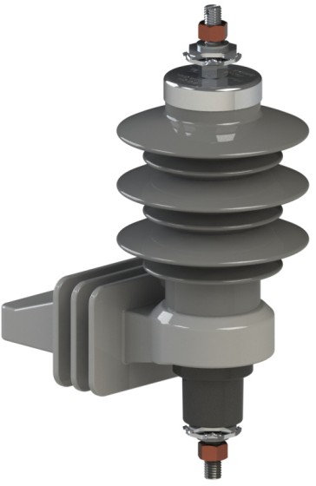
Distribution Arresters
Riser Pole Arrester Characteristics

Rated Voltage  3 | MCOV | FOW | Switching |  |  | Lightnin | g - 8/20
 |  |  |  | 1.5kA | 3kA | 5kA | 10kA | 20kA | 40kA
Rated Voltage  3 | 2.55 | 9.4 | 7.1 | 7.2 | 7.7 | 8.1 | 8.8 | 9.9 | 11.7
6 | 5.1 | 18.8 | 14.2 | 14.4 | 15.2 | 16.2 | 17.6 | 19.8 | 23.4
9 | 7.65 | 27.1 | 18.5 | 21 | 22.3 | 23.4 | 24.8 | 28.1 | 32.5
10 | 8.4 | 29.5 | 22 | 23.1 | 24.5 | 25.6 | 27.1 | 31 | 35.8
12 | 10.2 | 35.7 | 26.3 | 28.2 | 29.4 | 30.5 | 32.5 | 36.5 | 42.6
15 | 12.7 | 44.5 | 32.7 | 34.1 | 35.3 | 37.6 | 40.3 | 45.6 | 53
18 | 15.3 | 54.3 | 38.8 | 41.2 | 43.6 | 44.9 | 49 | 55.4 | 63.5
21 | 17 | 61 | 45.6 | 46.8 | 49.2 | 51.8 | 56.1 | 63.5 | 73.7
24 | 19.5 | 70.3 | 51.3 | 54.1 | 56.5 | 60.2 | 65 | 73.4 | 84.9
27 | 22 | 79.2 | 58 | 60.8 | 64.5 | 67.6 | 72.5 | 82.6 | 95
30 | 24.4 | 88.6 | 64.3 | 67.9 | 72.1 | 75.3 | 81.5 | 91.4 | 107.1
33 | 27 | 97.5 | 72.2 | 74.8 | 79.5 | 82.2 | 90 | 100.5 | 116.3
36 | 29 | 105 | 76.3 | 80.5 | 85.5 | 89.4 | 96.5 | 110 | 126.5

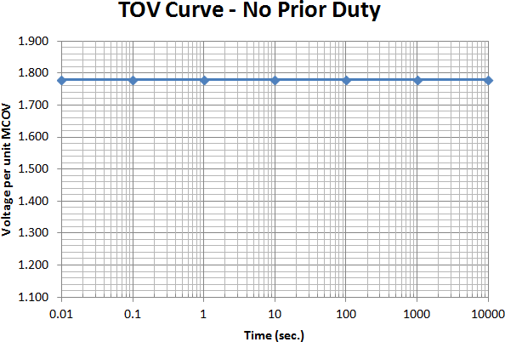
Distribution Arresters

“Titan” Arrester Characteristics

Rated Voltage  3 | MCOV | Min 60 Hz Sparkover | FOW | Switching | Lightning - 8/20
 |  |  |  |  | 1.5kA | 3kA | 5kA | 10kA | 20kA | 40kA
Rated Voltage  3 | 2.55 | 4.6 | 20 | 7.5 | 7.8 | 8.4 | 8.7 | 9.4 | 10.7 | 12.5
6 | 5.1 | 9.1 | 23 | 14.9 | 15.6 | 16.8 | 17.2 | 18.6 | 21.2 | 24.8
9 | 7.65 | 13.6 | 32.4 | 17.8 | 18.9 | 20.1 | 21 | 22.9 | 25.4 | 28.6
10 | 8.4 | 15 | 32.4 | 19 | 20 | 20.9 | 22.3 | 24.3 | 26.9 | 30.3
12 | 10.2 | 18.2 | 52.4 | 23.8 | 25.2 | 26.8 | 28 | 30.6 | 33.8 | 38.1
15 | 12.7 | 22.6 | 55.4 | 28.8 | 30 | 32.3 | 35 | 38.3 | 43.6 | 51
18 | 15.3 | 27.2 | 64.8 | 35.7 | 37.8 | 40.3 | 42.1 | 45.9 | 50.7 | 57.1
21 | 17 | 30.3 | 64.8 | 37.8 | 40 | 43.1 | 46.1 | 50.5 | 57.6 | 67
24 | 19.5 | 34.7 | 87.8 | 43.8 | 46.2 | 50 | 53.2 | 58.1 | 67 | 78
27 | 22 | 39.2 | 97.2 | 50.8 | 53.8 | 57.4 | 60 | 65.4 | 72.3 | 81.6
30 | 24.4 | 43.4 | 117.2 | 55.3 | 58.6 | 63.2 | 67.7 | 74 | 85 | 98
33 | 27 | 48.1 | 120.2 | 62.8 | 66.6 | 71.7 | 77 | 84 | 96 | 115
36 | 29 | 51.6 | 129.6 | 66.4 | 70.4 | 76 | 81 | 89 | 102 | 118
Titan Arrester has zero electrical losses through the MCOV disks during normal and TOV conditions, excluding the losses across the surface of the sheds which is highly dependent on pollution levels.


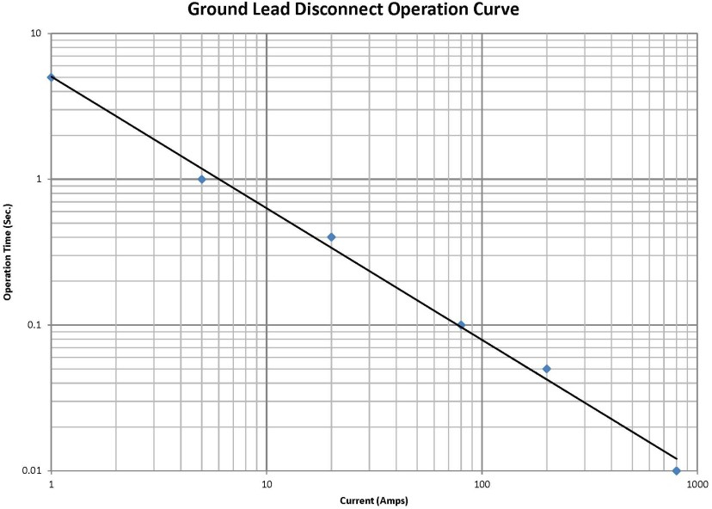
Distribution Arresters

Arrester Characteristics

Ground Lead Disconnect Curve
The Aluma-Form Ground Lead Disconnect (GLD) will operate efficiently down to 1 amp. Our GLD will operate in under 1 second at 5 amps. It will also operate in under 5 seconds at 1 amp. The following curve (below) shows the operating range of our GLD.

Catalog Name | Voltage Rating | Creepage (Inches) | Housing | Housing  Length "A" | B | C | D | E | Weight (lbs) | Isolator Bracket
AHD-03** | 3 | 9.1 | A | 3-13/16 | 9-1/8 | 4.25 | 6-5/8 | 9-9/16 | 2.9 | 1
AHD-06** | 6 | 13.4 | B | 5 | 10-5/16 | 4.25 | 7-13/16 | 10-3/4 | 3.1 | 1
AHD-09** | 9 | 13.4 | B | 5 | 10-5/16 | 4.25 | 7-13/16 | 10-3/4 | 3.2 | 1
AHD-010** | 10 | 13.4 | B | 5 | 10-5/16 | 4.25 | 7-13/16 | 10-3/4 | 3.2 | 1
AHD-012** | 12 | 17.3 | C | 6-1/2 | 11-7/8 | 5 | 9-3/8 | 12-5/16 | 4.2 | 2
AHD-015** | 15 | 25.2 | D | 8-13/16 | 14-15/16 | 5 | 12-7/16 | 15-3/8 | 4.5 | 2
AHD-018** | 18 | 25.2 | D | 8-13/16 | 14-15/16 | 6 | 12-7/16 | 15-3/8 | 4.5 | 3
AHD-021** | 21 | 29.1 | E | 10 | 15-1/4 | 6 | 12-3/4 | 15-3/4 | 5.1 | 3
AHD-024** | 24 | 33.5 | F | 11-1/4 | 16-1/2 | 6 | 14 | 16-7/8 | 5.5 | 3
AHD-027** | 27 | 33.5 | F | 11-1/4 | 16-1/2 | 6 | 14 | 16-7/8 | 5.5 | 3
AHD-030** | 30 | 42.3 | G | 13-3/4 | 19-5/16 | 6 | 17 | 19-3/4 | 6.5 | 3
AHD-033** | 33 | 42.3 | G | 13-3/4 | 19-5/16 | 6 | 17 | 19-3/4 | 6.5 | 3
AHD-036** | 36 | 49.4 | H | 15-11/16 | 20-15-16 | 6 | 18-7/16 | 21-3/8 | 7.8 | 3
** For riser pole change “AHD” to “ARP”

Distribution Arresters

Heavy Duty & Riser Pole Arresters Exploded View
Wildlife Protection Cap

Silicone Bronze or

Stainless Steel nut 4 Corner Washer
Stainless Steel Stud Protective Cap

Hermetically Sealed silicone housing containing MOV blocks
Lock Washer

Isolator Bracket

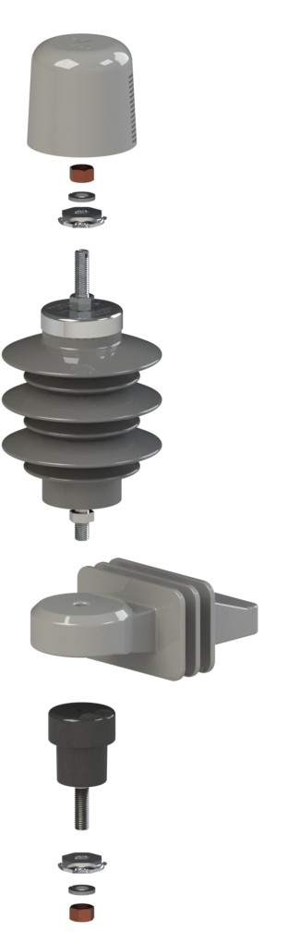
Ground Lead Disconnect
Stainless Steel Stud 4 Corner Washer
Silicone Bronze or Stainless Steel nut

Lock Washer

Distribution Arresters
Heavy Duty & Riser Pole Arresters
AHD-10B-1GX-4X1-4X-B

Arrester Type

eavy Duty
Additional Options

AHD = Arrester H
ARP = Arrester Riser Pole
*Add a -T for Titan or -D for Directional
kV Rating of Arrester
03 – 3kV 15 – 15kV
06 – 6kV 18 – 18kV
09 – 9kV 21 – 21kV 30 - 30kV
10 – 10kV 24 – 24kV 33 - 33kV
12 – 12kV 27 – 27kV 36 - 36kV

Housing Size
A – Hsg A (3kV)
B - Boss Mounting Hardware (only with mounting brackets options C, D &E)

Ground Lead (Bottom)
A – 18” #6 Insulated Wire Lead, strip 1.25”

B – Hsg B (6, 9, 10kV)
C – Hsg C (12)
D – Hsg D (15 & 18kV)
both ends
B – 18” #6 Insulated
1.25”/ ring term.

Wire Lead, strip

E – Hsg E (21kV) G - Hsg G (30 & 33kV)
F – Hsg F (24 & 27kV) H - Hsg H (36kV)

Isolator Bracket Size
- – Size 1 Isolator (3-12kV)
- – Size 2 Isolator (15-24kV)
- – Size 3 Isolator (27kV)
Ground Lead Disconnect
G – with GLD
X – without GLD
Mounting Bracket options
A – Nema A Crossarm
B – Nema B Crossarm
C – Transformer, small
D – Transformer, medium
E – Transformer, large X – No Bracket
Hardware (Top of Arrester)
- – Std nut, 4-corner, flat wash., lock wash.
- – Std nut, two 4-corner, lock wash.
- – Si Bronze nut, 4-corner, flat wash., lock wash.
- – Si Bronze nut, two 4-corner, lock wash.
- – SS nut, lock wash., flat wash.
- – Si Bronze nut, lock wash., flat wash.
- - No First Hex nut, SS nut, 4-corne, lock wash X – No hardware

Line Lead (Top of Arrester)
A – 18” #6 Insulated Wire Lead, strip 1.25” both ends
B – 18” #6 Insulated Wire Lead, strip 1.25”/ ring term.
C – 18” #6 Insulated Wire Lead, 2 ring term.
D – Overhead Primary Tap - #2-556 Al or Cu
E - 84” #6 Insulated Wire Lead, strip 1.25”/ ring term
F - 12” #4 Tinned Copper Braided Conductor X – No line term. wire
C – 18” #6 Insulated Wire Lead, 2 ring term.
D – 12” Copper Strap
X – No ground term. wire

Hardware (Bottom)
- – Std nut, 4-corner, flat wash., lock wash.
- – Std nut, two 4-corner, lock wash.
- – Si Bronze nut, 4-corner, flat wash., lock wash.
- – Si Bronze nut, two 4-corner, lock wash.
- – SS nut, lock wash., flat wash.
- – Si Bronze nut, lock wash., flat wash.
X – No hardware
Top (options)
- – Wildlife protection cap
- – Flipper fuse kit X – No option

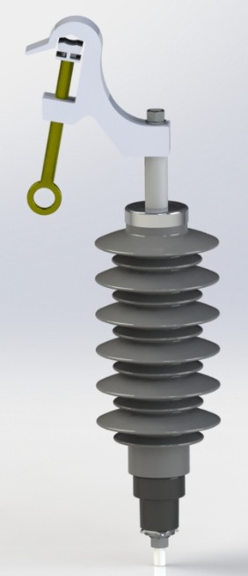
Distribution Arresters

Line Lead Option

Overhead Primary Tap #2-556 Al or Cu

Distribution Arresters

Arrester Mounting Options

NEMA “A” Small Transformer Bracket

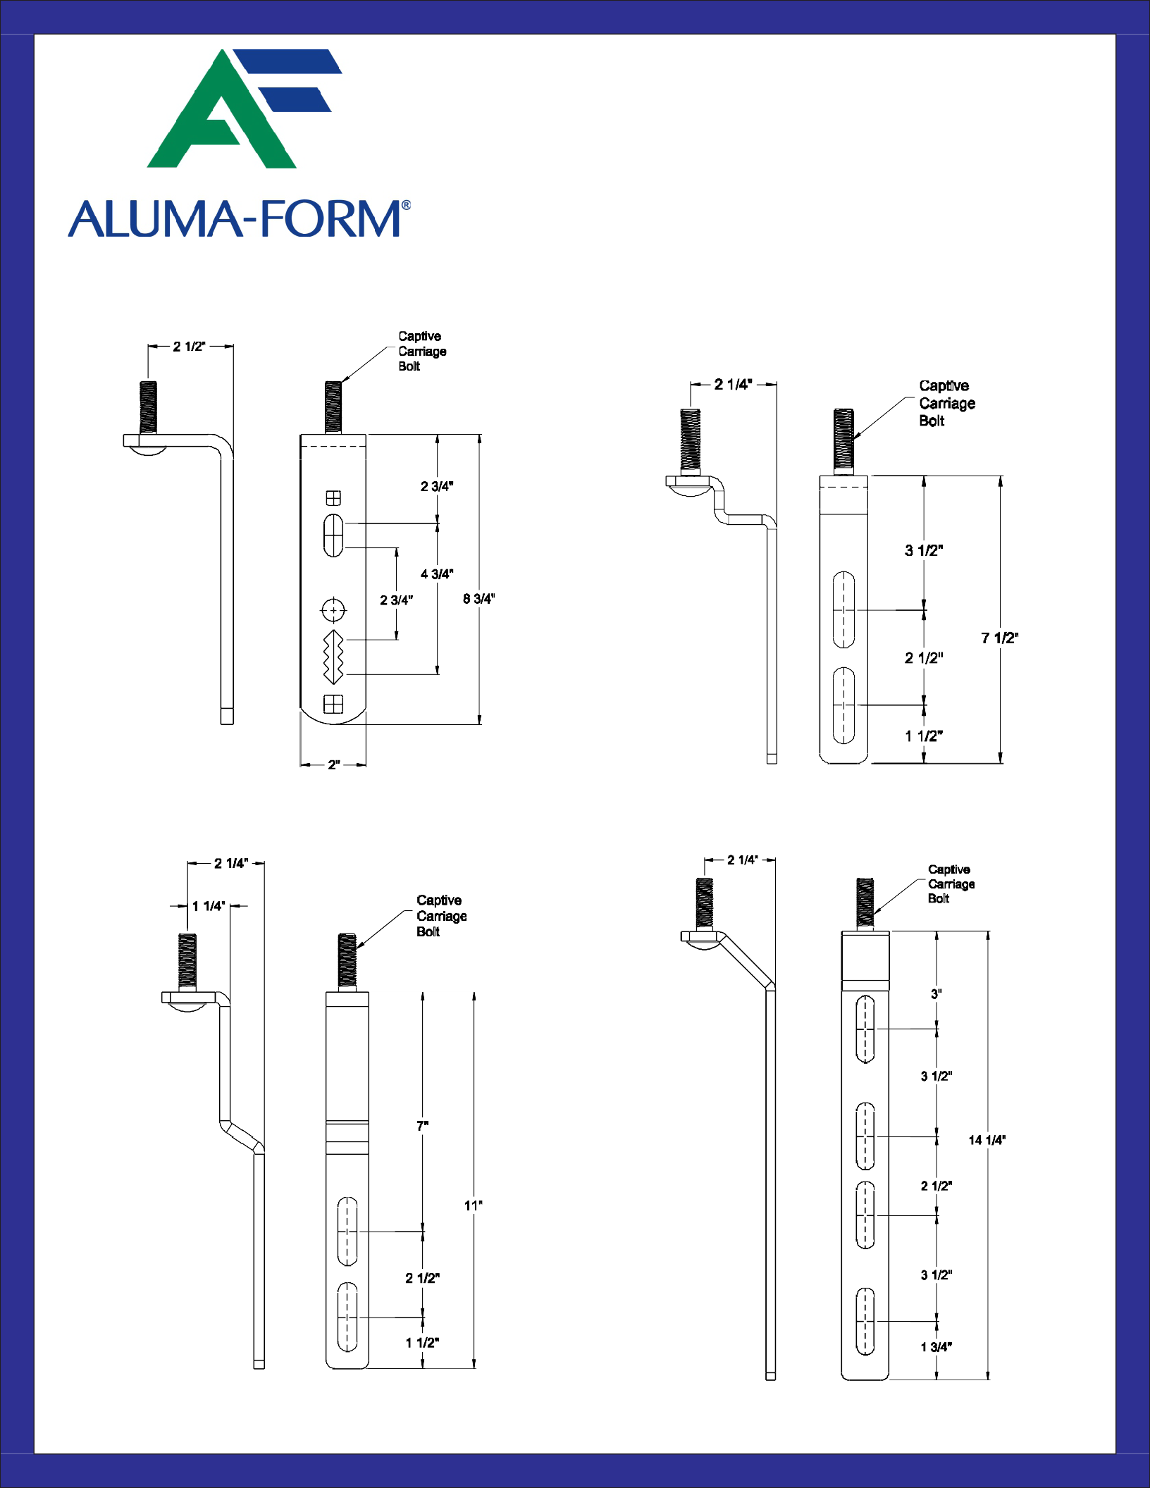
Medium Transformer Bracket
Large Transformer Bracket

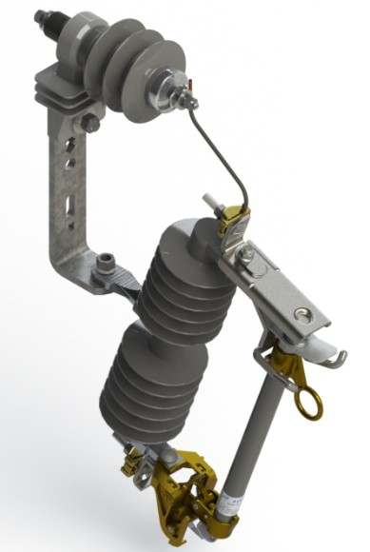
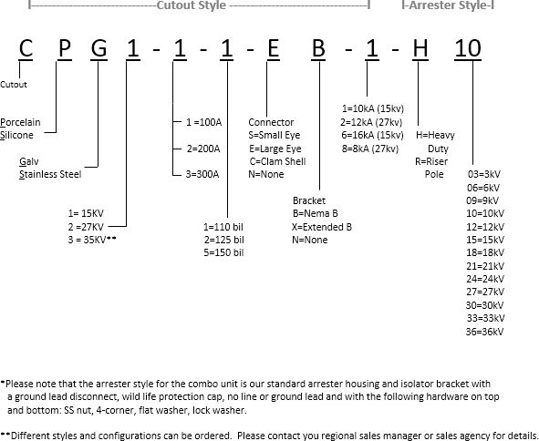
Cutout / Arrester Combo

COPYRIGHT © UNPUBLISHED ALUMA-FORM, Inc. MEMPHIS, TENNESSEE U.S.A. ALL RIGHTS RESERVED

NOTE:
  - GENERAL VIEWS SHOWN WITHOUT WILDLIFE CAP FOR HARDWARE ILLUSTRATION
DUPLICATION, DISTRIBUTION OR ALTERATION OF THIS DOCUMENT BY ANY MEANS, IN WHOLE OR IN PART, IS STRICTLY FORBIDDEN. ALL INFORMATION HEREIN DISCLOSED, WHETHER PATENTABLE OR OTHERWISE, IS THE CONFIDENTIAL, PROPRIETARY AND INTELLECTUAL PROPERTY OF ALUMA-FORM, INC. ANY USE OR PUBLICATION
OF THIS DOCUMENT OR CONTAINED INFORMATION, WITHOUT FIRST OBTAINING EXPLICIT WRITTEN AUTHORIZATION FROM ALUMA-FORM, INC. , IS ABSOLUTELY FORBIDDEN.
  - ALL DIMENSIONS FOR REFERENCE ONLY
  - TOP AND BOTTOM NUT SHALL BE HAND TIGHTENED ONLY ENOUGH TO SECURE WASHERS

ARRESTER SHOWN WITH WILDLIFE CAP
2
ITEM NO. | PART NUMBER | DESCRIPTION | QTY
1 | 48051-07 | ARP-18D-1G, ASSEMBLY | 1
2 | 25224 | WILDLIFE CAP, ARRESTER | 1
3 | 30541 | NUT, HEX, 3/8" Silicon Bronze | 2
4 | 30398 | 3/8" REGULAR HELICAL LOCKWASHER, S.S. | 2
5 | 30420 | WIRE CLAMP, ARRESTER | 4
- | 18162 | BOLT PACK, PRESSFIT NEMA A BRACKET | 1
- | 67777-05 | LABEL, ARRESTER RATING, 18kV | 1
- | 67778-02 | LABEL, ARRESTER TYPE, RP | 1

1

4 1/4" REF
6 15/16" REF
Directional Arrester
A

Direction Indicator

3
5
4

5
4

14" 3
REF
120°

4 1/16" REF
DETAIL A SCALE 1 : 1

B
DETAIL B SCALE 1 : 1

"D" added in part number to indicate directional.

CHANGE / REVISION DESCRIPTION

JOB NUMBER
UNLESS OTHERWISE SPECIFIED, STANDARD ALUMA-FORM, INC. MANUFACTURING TOLERANCES APPLY

- ALUMA-FORM, Inc.
59049
DRAWING NUMBER
-
REVISION
3625 OLD GETWELL ROAD MEMPHIS, TN 38118-6072 U.S.A.
SCALE

PROJECT CODE WEIGHT
1:4

2.88
DESCRIPTION

MATERIAL SECTION
RP ARRESTER, ARP-D-18D-1GA-4X1-4X

59049 -

LYW 5780 22-DEC-16

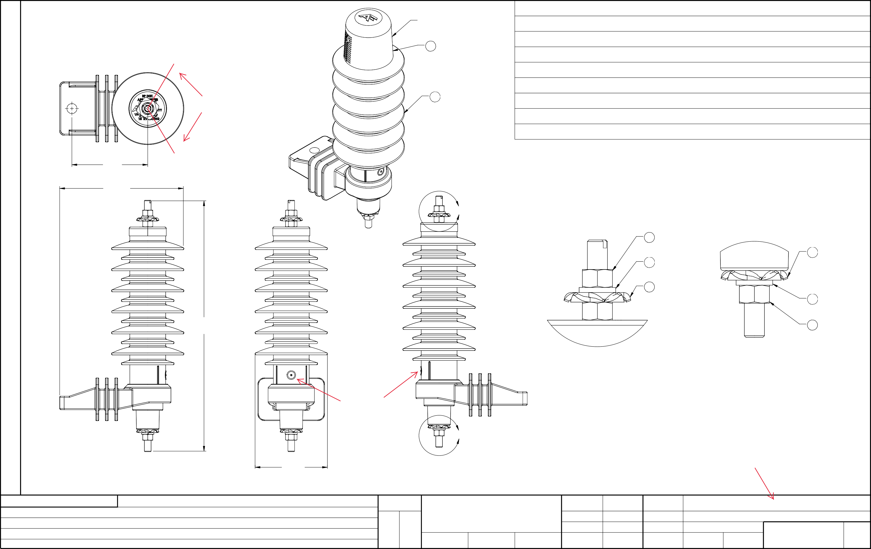
DRAWN BY
RELEASE E.A.
RELEASE DATE
REVISED BY
REVISED E. A.
REVISED DATE
REVIEWED APPROVED
DRAWING NUMBER
REVISION

